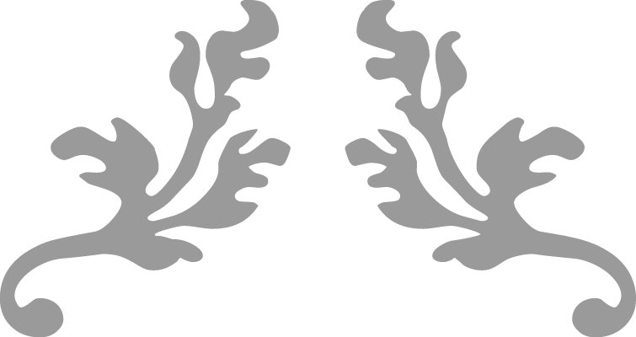

Craft Portfolio

Two Pipe Heating System

Phase 2 Plumbing

Aidan Whelan

20th march 2019



Table of Contents

Summary 2

The Project 2

Self-Reflection 6

# Summary

In this portfolio, I will explain how I installed a two pipe open vented heating system, which had many critical points such a heated bends, hop overs, offsets, butt welds, branch welds, and machine bends.

# The Project

In this examination, we had to display our skills as plumbers by installing a two pipe open vented heating system, which had three radiators, a boiler, a feed and expansion tank, and a cylinder

We were tasked with showing how well we used what we had been learning in the classroom and during the practical classes and applying it during our practical exam.

There was many different skills we learned which we had then had to apply in our practical exam such as different types of oxy-acetyl welding, we had to incorporate butt welds and branch welds.

We learnt the correct way to apply thread seals using flax and boss white/uni-white, and the correct way to safely cut and thread GB pipe, we also learned how to use the threading machine.

The picture shows some of the tools I required such as a copper benders, oxy-acetyl equipment, pipe slice, grips and an adjustable spanner. I also used the threading machine and a hydraulic benders

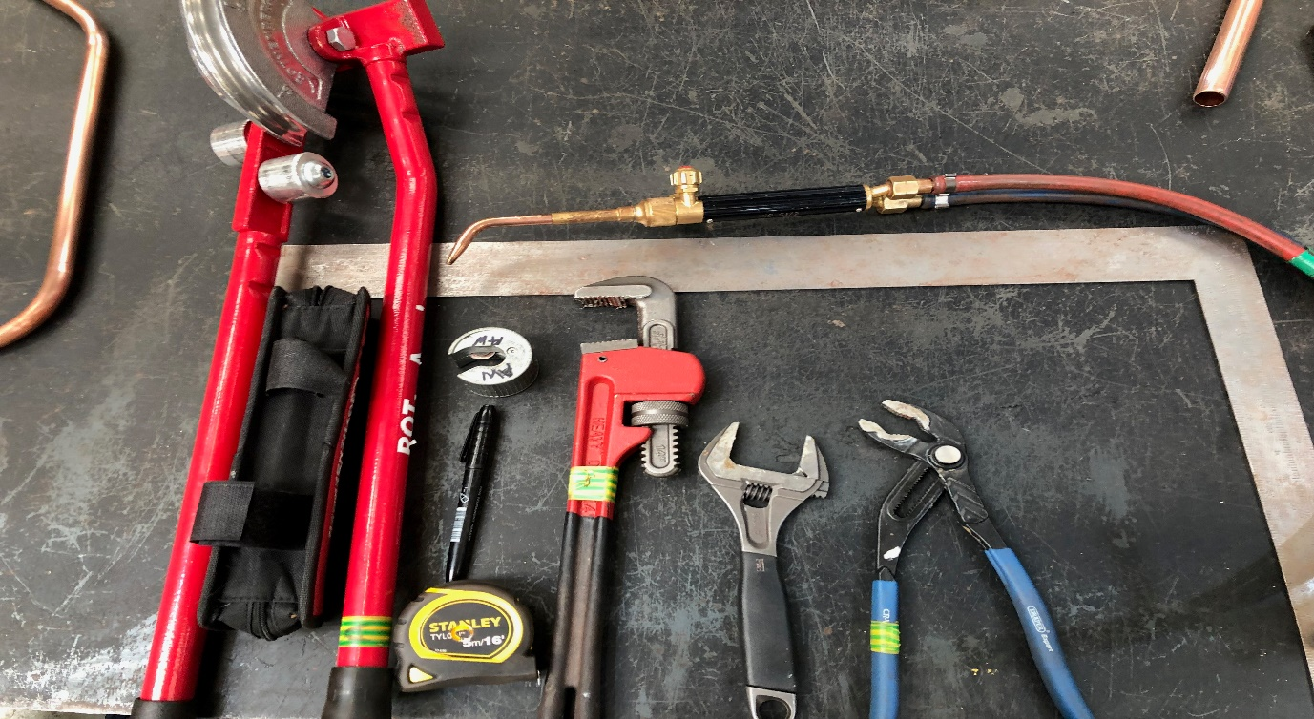

I Began My project my first thinking about how I would space out my time evenly so I would not be stuck for time towards the end of the project.

I began by hanging my radiator brackets making sure they were the correct height and making sure that they were level.

Once I had my radiator brackets securely screwed to the wall, I check them again making sure that they were the correct height and that they were level. I then placed my radiators on the wall and began piping them.

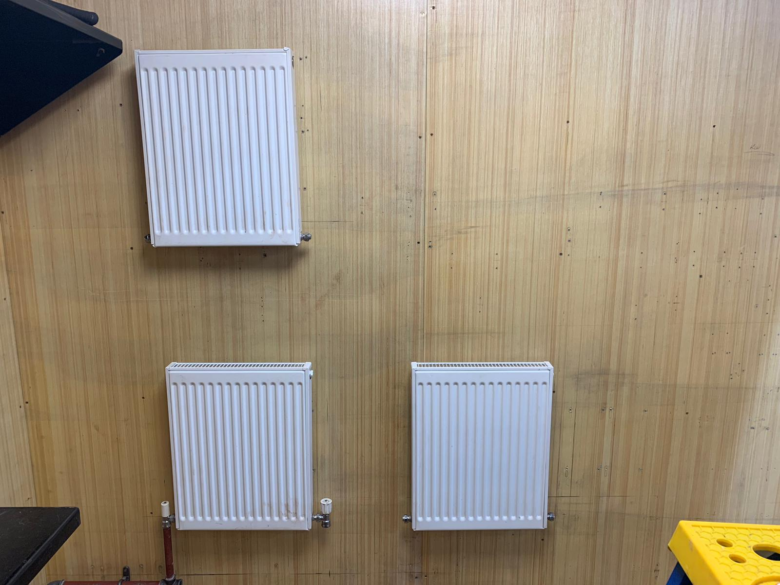

Once I was happy with the brackets I they placed the radiators on the brackets and I outlined a pencil line around the radiators which I would remove when I was finished, this line was to make sure that if the radiators moved I would know that they weren’t in the correct place anymore.

Once I was happy with the radiators I began by putting two ¾ gb brackets on the back wall with two elbows looking out towards the right hand wall (radiator side), I they ran a piece of pipe with a T-piece which then had the radiator valve and connected to the left side of the radiator, I did the same for the bottom pipe.

On the bottom pipe I needed to put in one machine made hop over, and one heat made hop over, these hop overs needed to be branch welded onto the pipe.

I also made my machine double bends and the two 45 degree off sets.

First I made the both hop overs and then I had to file both ends of the pipe so they would fit into each other tightly.

I then began to weld the pipe though a technique that I learned and practiced in class. I made sure that the pipes I was welding on didn’t move because if they did they wouldn’t line up with the other side of the radiator.

I then started to dress all the fittings with flax and uni white, and I hooked up all the radiators.

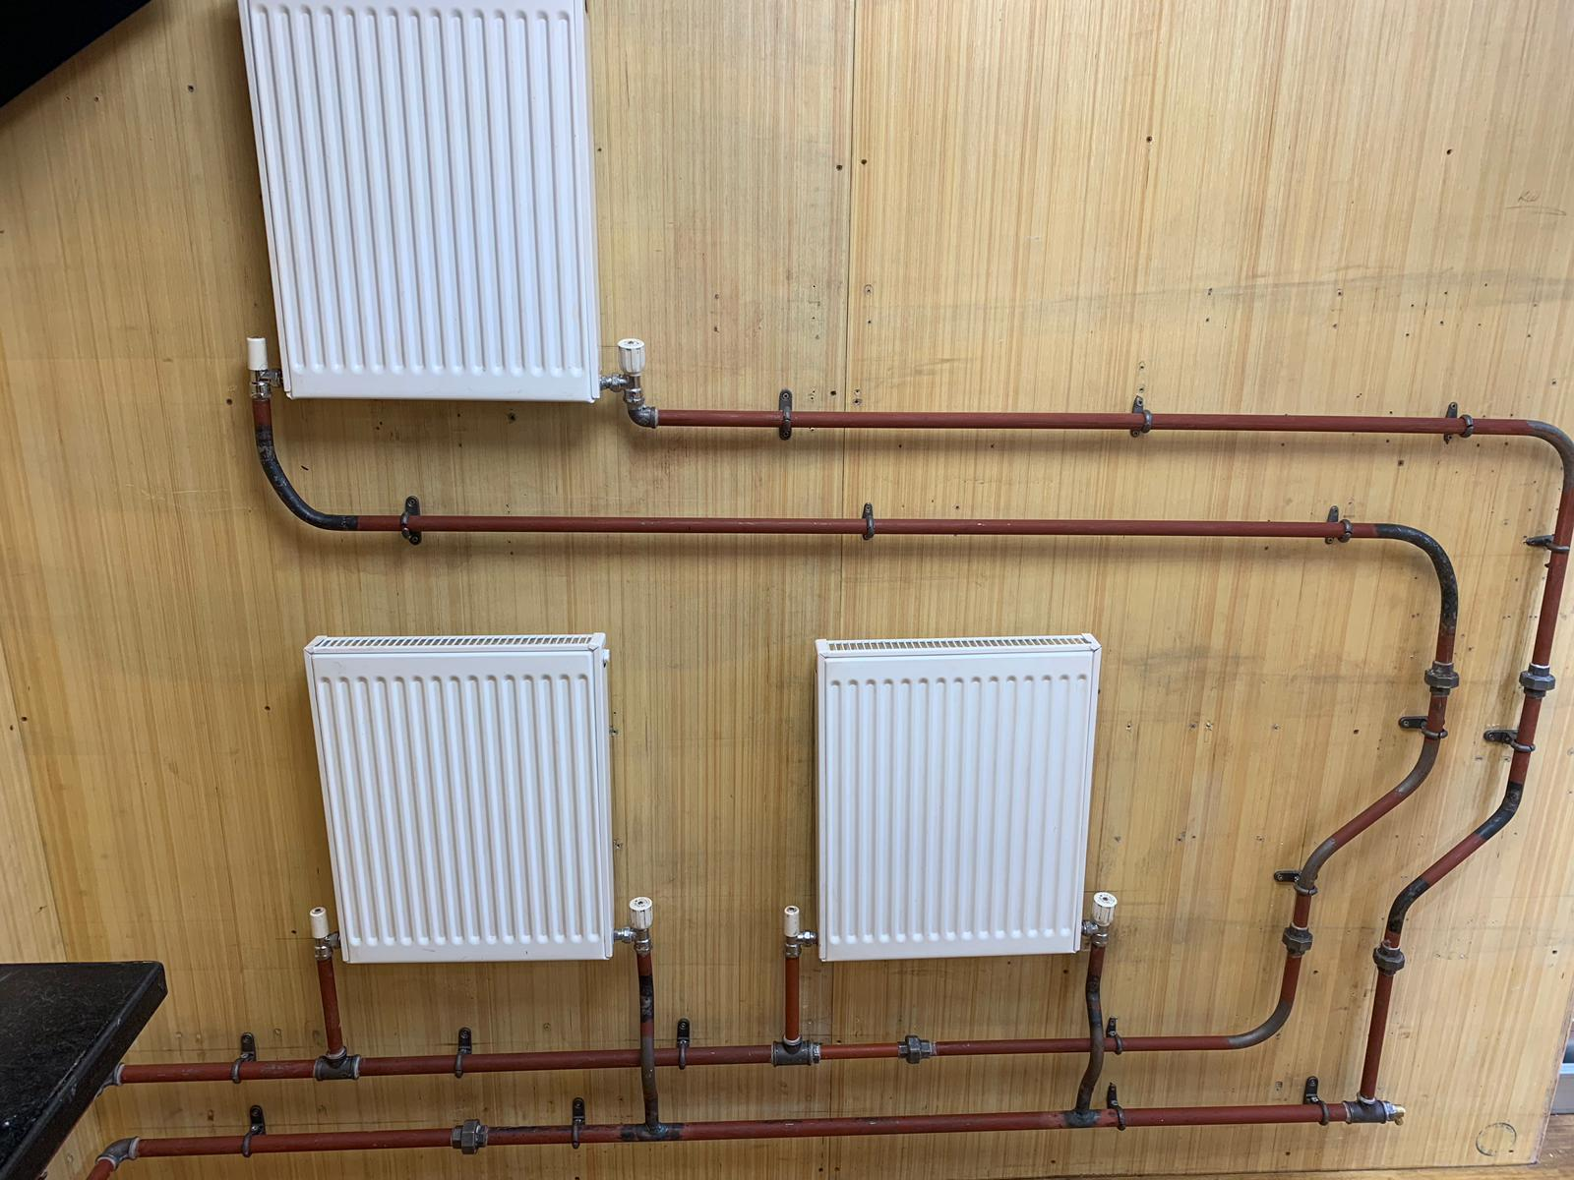

Once I had the right hand wall completed I then piped my primary flow and return along the back wall and over to the left hand wall.

I needed to install a pump on the primary flow to help circulate the water around the heating system.

I put my boiler in place and then piped it up.

I also needed to install a drain off, and a PRV

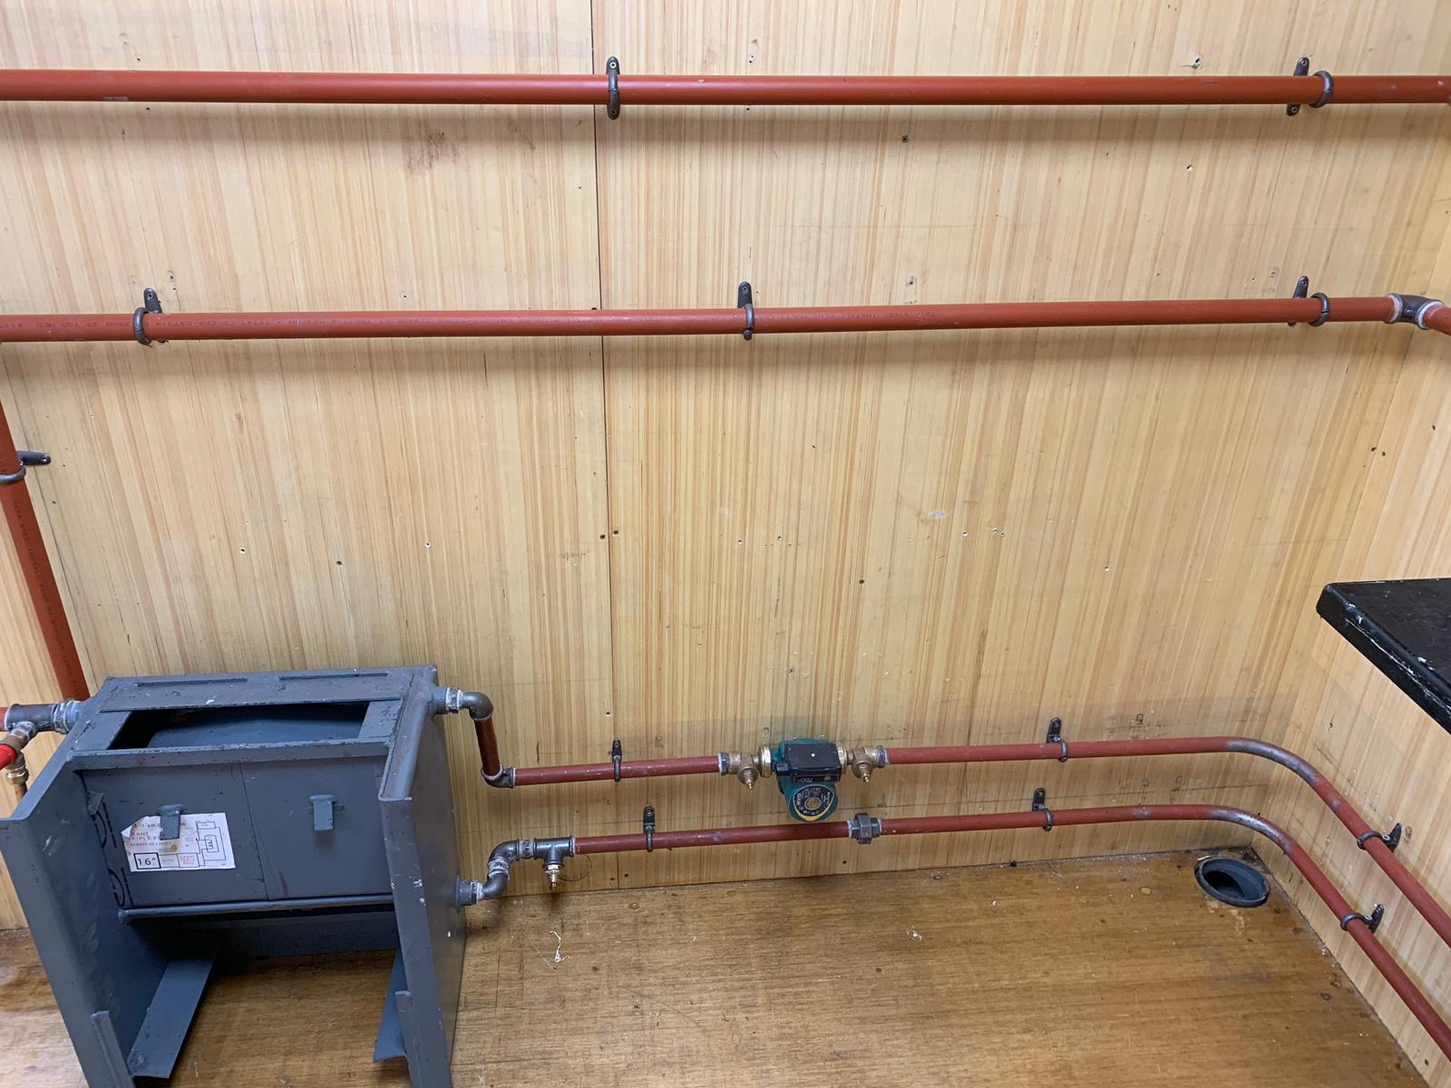

I then piped my primary flow and return over along the boiler making sure that there wasn’t any fall going down into the copper cylinder.

Once I was onto the cylinder I installed my feed and expansion tank with the suitable ballcock, and I made sure that my 350’s were tight and that they were on properly. I then piped my expansion and the cold feed into the cylinder, I also put a LABV on the cold feed so I would be able to turn it off in ease.

# Self-Reflection

During my time spent doing this exam I learned the importance of union fitting, I also learned to inspect my pipe for any bowing because I installed a length of gb pipe and there was a bow in it, which will look unsightly and may affect the functionally of the heating system.

Next time when installing a feed and expansion tank I would have the overflow piped first as I found it a bit tight for space and awkward when I installed my tank and had it hooked up

During my time spent at Kerry ETB Training Centre I have learned many valuable skills such as soldering, welding, cupro tech welding, brazing which I will hopefully be using in phase 3 when I return to the workplace with my employer.